Find out More  For questions about your data, please contact:  Sf.health@nhs.net   |  |  |  |  |   Your Data and the New Law  - Important changes to how GP practices use and share your information since the introduction of the Data (Use and Access) Act 2025.  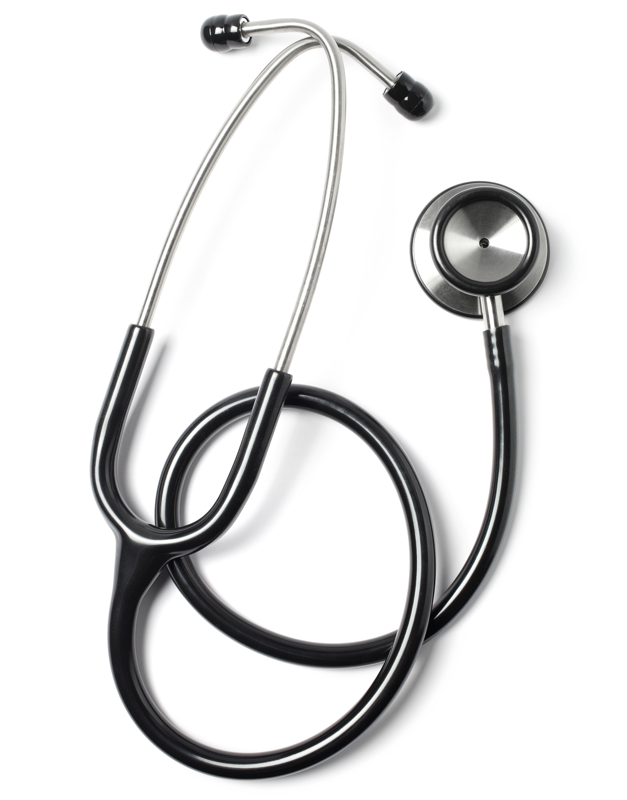

Why are things changing?  The UK Government has updated data protection law to:  - Strengthen patients’ rights  - Give organisations clearer rules  - Improve how data is used in safeguarding, emergencies and public interest situations.  These updates affect both patients and GP practices.  Your Rights to Access your Data (SARs)  - You can ask for a copy of your personal information  - We must respond within one month (with some exceptions) | - If your request is unclear, we may ‘pause the clock’ until you clarify  - We will search records in a reasonable and proportionate way  - In some cases, some information may be withheld (eg if it contains another person’s details or could cause serious harm)  - If you disagree with the withholding of some of the data, the court can now inspect the withheld data directly and decide if it should be shared.  New Lawful Basis: Recognised Legitimate Interests  We may use or share your data without your consent if it is in the public interest, for example:  - Safeguarding children or vulnerable adults  - Preventing or detecting crime  - Responding to emergencies.  This is called Recognised Legitimate Interests. It means the law already recognises these uses as justified. | Reusing Data for New Purposes (Further Processing)  Normally, we only use your data for the purpose it was collected – to provide your healthcare. The new laws allows us to reuse it if it is clearly in the public interest, such as:  - Sharing information with social services if we have safeguarding concerns  - Helping the police with serious crime investigations  - Using patient contact details during a local health emergency.  We will always:  - Use only minimum data necessary  - Keep the use of the data lawful, necessary and proportionate  - Be open and transparent through our Privacy Notice.

